CHAPTER 18
Neural Control and Coordination

The functions of the organs/organ systems in our body must be coordinated to maintain homeostasis.
• Coordination - the process through which two or more organs interact and complement the functions of one another.
Worked example - physical exercise. When we do physical exercises the energy demand is increased for maintaining an increased muscular activity, and the supply of oxygen is also increased. That increased oxygen supply necessitates an increase in the rate of respiration, heart beat and increased blood flow via blood vessels. When physical exercise is stopped, the activities of nerves, lungs, heart and kidney gradually return to their normal conditions. Thus the functions of muscles, lungs, heart, blood vessels, kidney and other organs are coordinated while performing physical exercises.
System | How it coordinates | Nature of the link
Neural system | Provides an organised network of point-to-point connections | For a quick coordination
Endocrine system | Provides chemical integration | Through hormones

In our body the neural system and the endocrine system jointly coordinate and integrate all the activities of the organs so that they function in a synchronised fashion.
18.1 | Neural System

• Neurons - the neural system of all animals is composed of highly specialised cells called neurons, which can detect, receive and transmit different kinds of stimuli.
Animal group | Level of neural organisation
Lower invertebrates | Neural organisation is very simple.
Hydra | Composed of a network of neurons.
Insects | The neural system is better organised: a brain is present along with a number of ganglia and neural tissues.
Vertebrates | Have a more developed neural system.

18.2 | Human Neural System

The human neural system is divided into two parts: (i) the central neural system (CNS) and (ii) the peripheral neural system (PNS).
• CNS - includes the brain and the spinal cord, and is the site of information processing and control.
• PNS - comprises all the nerves of the body associated with the CNS (brain and spinal cord).
The nerve fibres of the PNS are of two types: (a) afferent fibres and (b) efferent fibres.
Fibre type | Direction of the impulse | What it carries
Afferent nerve fibres | From tissues/organs to the CNS | Sensory input arriving at the CNS
Efferent fibres | From the CNS to the concerned peripheral tissues/organs | Regulatory impulses

The PNS is divided into two divisions called the somatic neural system and the autonomic neural system.
Division of the PNS | Relays impulses from the CNS to
Somatic neural system | Skeletal muscles
Autonomic neural system | The involuntary organs and smooth muscles of the body

• The autonomic neural system is further classified into the sympathetic neural system and the parasympathetic neural system.
• Visceral nervous system - the part of the peripheral nervous system that comprises the whole complex of nerves, fibres, ganglia and plexuses by which impulses travel from the central nervous system to the viscera and from the viscera to the central nervous system.
[NOTE] NCERT's own text names spinal and cranial nerves only once, as the place where myelinated nerve fibres are found (18.3), and never defines either. Both are PNS nerves and they are told apart by where they leave the CNS: cranial nerves arise from the brain, while spinal nerves arise from the spinal cord. Each carries afferent fibres, efferent fibres, or both.

18.3 | Neuron as Structural and Functional Unit of Neural System

A neuron is a microscopic structure composed of three major parts, namely, cell body, dendrites and axon (Figure 18.1).
Part of the neuron | Structure | Function
Cell body | Contains cytoplasm with typical cell organelles and certain granular bodies called Nissl's granules | The metabolic centre of the neuron; impulses arrive here from the dendrites
Dendrites | Short fibres which branch repeatedly and project out of the cell body; they also contain Nissl's granules | Transmit impulses towards the cell body
Axon | A long fibre, the distal end of which is branched; each branch terminates as a bulb-like structure called a synaptic knob, which possesses synaptic vesicles containing chemicals called neurotransmitters | Transmits nerve impulses away from the cell body to a synapse or to a neuro-muscular junction

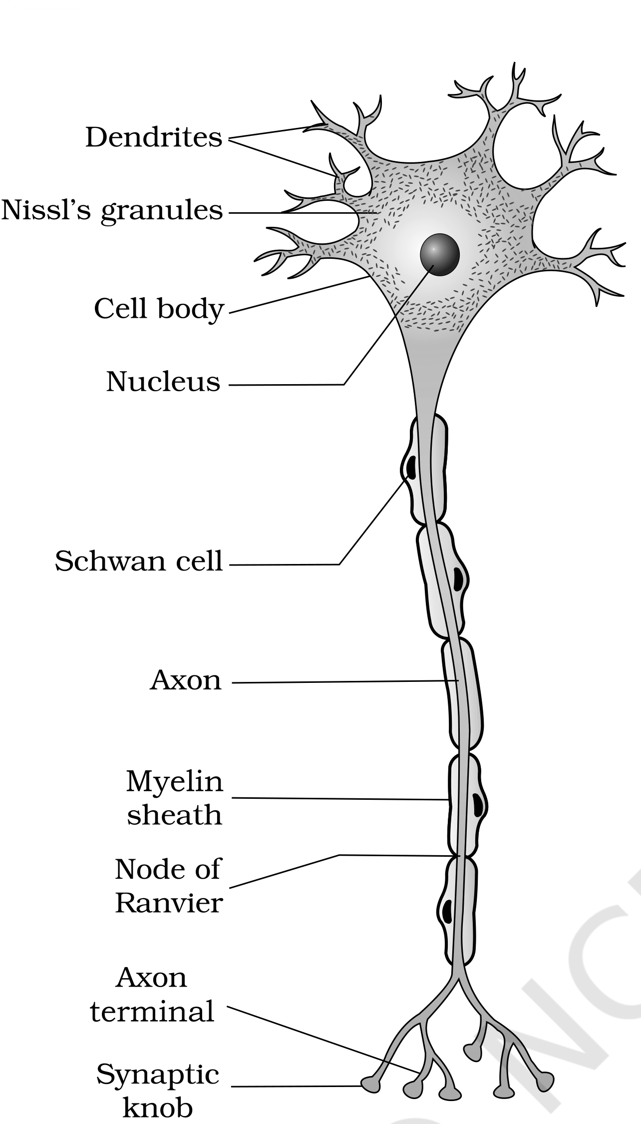
Fig. 18.1 - Structure of a neuron
Based on the number of axon and dendrites, the neurons are divided into three types.
Type | Axon and dendrites | Where found
Multipolar | One axon and two or more dendrites | Cerebral cortex
Bipolar | One axon and one dendrite | Retina of eye
Unipolar | Cell body with one axon only | Found usually in the embryonic stage

There are two types of axons, namely, myelinated and non-myelinated.
Feature | Myelinated nerve fibre | Unmyelinated nerve fibre
Schwann cells | Enveloped with Schwann cells, which form a myelin sheath around the axon | Enclosed by a Schwann cell that does not form a myelin sheath around the axon
Gaps in the sheath | The gaps between two adjacent myelin sheaths are called nodes of Ranvier | No myelin sheath, hence no nodes of Ranvier
Where found | Spinal and cranial nerves | Commonly found in autonomous and the somatic neural systems

[MEMORY AID - not in NCERT] Neuron traffic direction: Dendrites Deliver in, Axons Away. Both carry Nissl's granules only on the dendrite side of the cell body.

18.3.1 | Generation and Conduction of Nerve Impulse

Neurons are excitable cells because their membranes are in a polarised state.
• Different types of ion channels are present on the neural membrane, and these ion channels are selectively permeable to different ions.
• At rest (a neuron not conducting any impulse) the axonal membrane is comparatively more permeable to potassium ions (K⁺) and nearly impermeable to sodium ions (Na⁺).
• Similarly, the membrane is impermeable to negatively charged proteins present in the axoplasm.
Compartment | K⁺ | Na⁺ | Negatively charged proteins
Axoplasm (inside the axon) | High concentration | Low concentration | High - trapped inside
Fluid outside the axon | Low concentration | High concentration | Not stated by NCERT

These opposed concentrations form a concentration gradient across the membrane.
• Sodium-potassium pump - the ionic gradients across the resting membrane are maintained by the active transport of ions by this pump, which transports 3 Na⁺ outwards for 2 K⁺ into the cell.
As a result, the outer surface of the axonal membrane possesses a positive charge while its inner surface becomes negatively charged, and the membrane is therefore polarised.
• Resting potential - the electrical potential difference across the resting plasma membrane.
Now the mechanism of generation of a nerve impulse and its conduction along an axon.
1 | A stimulus is applied at a site (Figure 18.2, e.g., point A) on the polarised membrane; the membrane at site A becomes freely permeable to Na⁺.
2 | This leads to a rapid influx of Na⁺, followed by the reversal of the polarity at that site: the outer surface becomes negatively charged and the inner side becomes positively charged. The polarity at site A is thus reversed and hence depolarised.
3 | The electrical potential difference across the plasma membrane at site A is called the action potential, which is in fact termed as a nerve impulse.
4 | At sites immediately ahead - the axon at site B - the membrane still has a positive charge on the outer surface and a negative charge on its inner surface.
5 | As a result, a current flows on the inner surface from site A to site B; on the outer surface current flows from site B to site A (Figure 18.2), completing the circuit of current flow.
6 | Hence the polarity at the site is reversed and an action potential is generated at site B - i.e. the impulse (action potential) generated at site A arrives at site B.
7 | The sequence is repeated along the length of the axon and consequently the impulse is conducted.

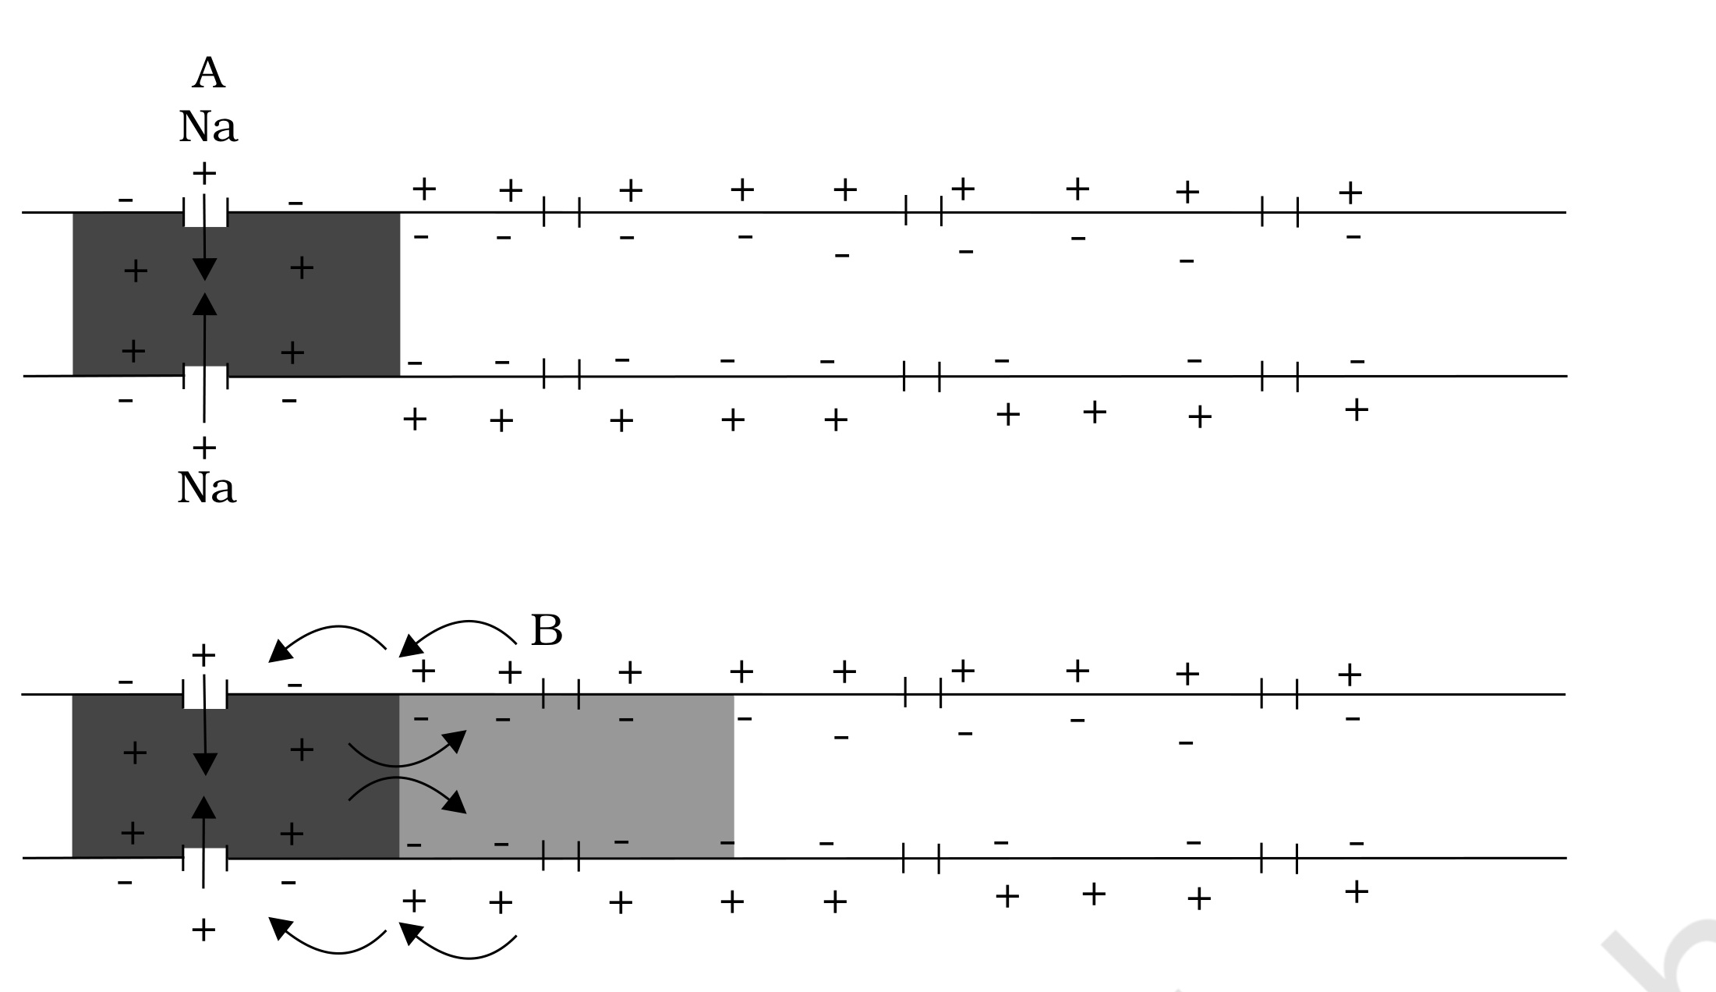
Fig. 18.2 - Diagrammatic representation of impulse conduction through an axon (at points A and B)
Restoring the resting state. The stimulus-induced rise in permeability to Na⁺ is extremely short-lived. It is quickly followed by a rise in permeability to K⁺. Within a fraction of a second, K⁺ diffuses outside the membrane and restores the resting potential of the membrane at the site of excitation, and the fibre becomes once more responsive to further stimulation.
[NOTE] The impulse travels as a wave. Taken end to end, the nerve impulse is conducted along the axon membrane in the form of a wave of depolarisation and repolarisation: depolarisation sweeps forward site by site while the sites just behind it are already being repolarised.

[NOTE] The chapter defines both fibre types (18.3) but never contrasts how they conduct. In an unmyelinated fibre the bare membrane is depolarised at every successive point, exactly as the A-to-B sequence above describes, so conduction is continuous and slower. In a myelinated fibre the myelin sheath insulates the axon and the membrane is exposed only at the nodes of Ranvier, so the impulse is regenerated node to node - saltatory (jumping) conduction, which is faster and uses less energy.

18.3.2 | Transmission of Impulses

A nerve impulse is transmitted from one neuron to another through junctions called synapses.
• Synapse - formed by the membranes of a pre-synaptic neuron and a post-synaptic neuron, which may or may not be separated by a gap called the synaptic cleft.
There are two types of synapses, namely, electrical synapses and chemical synapses.
Feature | Electrical synapse | Chemical synapse
Membranes | Membranes of pre- and post-synaptic neurons are in very close proximity | Membranes of the pre- and post-synaptic neurons are separated by a fluid-filled space called the synaptic cleft (Figure 18.3)
How the impulse crosses | Electrical current can flow directly from one neuron into the other across these synapses | Chemicals called neurotransmitters are involved in the transmission of impulses
Resemblance | Transmission is very similar to impulse conduction along a single axon | A fresh potential must be generated in the post-synaptic neuron
Speed | Always faster than that across a chemical synapse | Slower
Occurrence | Rare in our system | The usual synapse in our system

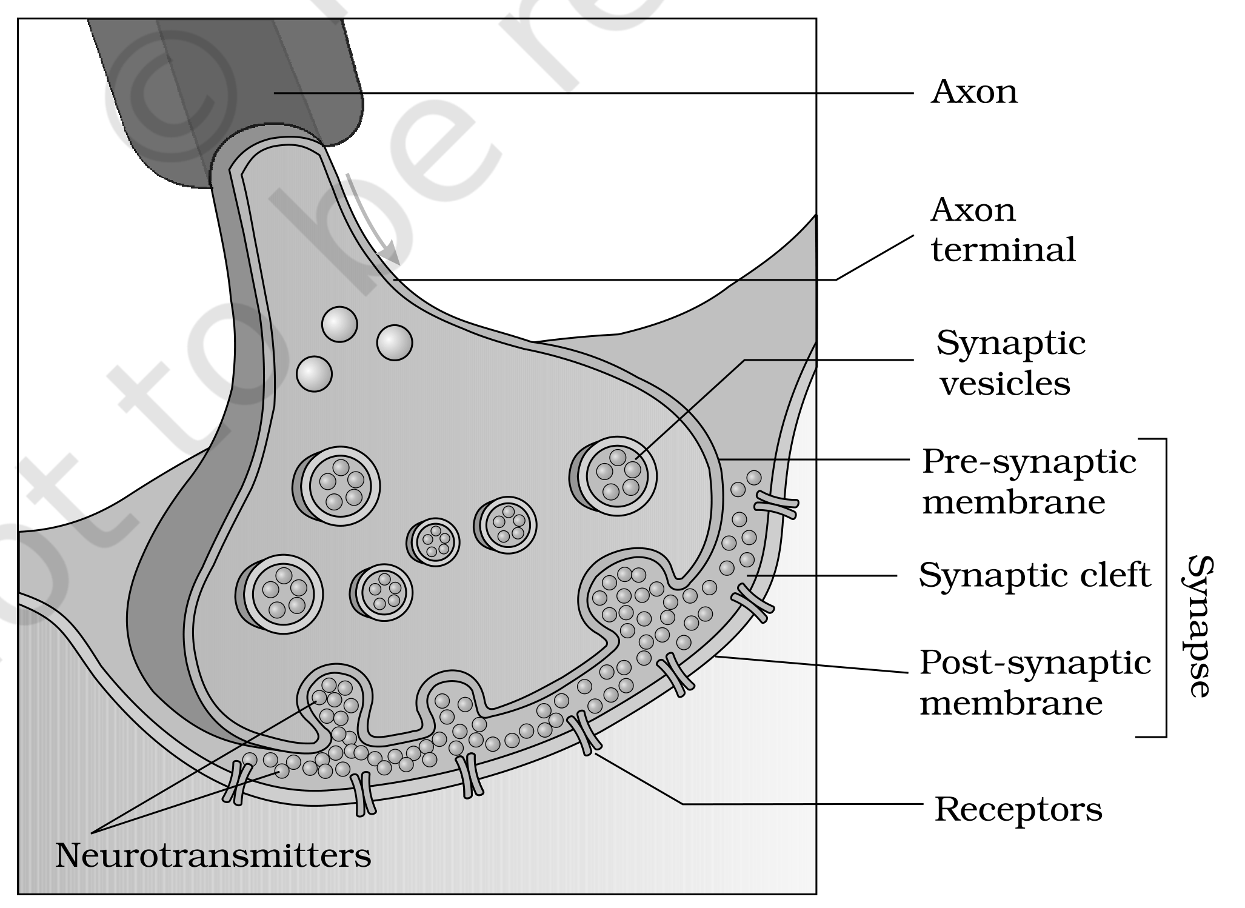
Fig. 18.3 - Diagram showing axon terminal and synapse
1 | The axon terminals contain vesicles filled with neurotransmitters.
2 | When an impulse (action potential) arrives at the axon terminal, it stimulates the movement of the synaptic vesicles towards the membrane.
3 | The vesicles fuse with the plasma membrane and release their neurotransmitters in the synaptic cleft.
4 | The released neurotransmitters bind to their specific receptors, present on the post-synaptic membrane.
5 | This binding opens ion channels, allowing the entry of ions which can generate a new potential in the post-synaptic neuron.
6 | The new potential developed may be either excitatory or inhibitory.

18.4 | Central Neural System

The brain is the central information processing organ of our body, and acts as the 'command and control system'.
What the brain does | Items NCERT lists
Controls | Voluntary movements; balance of the body; functioning of vital involuntary organs (e.g., lungs, heart, kidneys, etc.); thermoregulation; hunger and thirst; circadian (24-hour) rhythms of our body; activities of several endocrine glands; and human behaviour
Site for processing of | Vision, hearing, speech, memory, intelligence, emotions and thoughts

Protection. The human brain is well protected by the skull. Inside the skull the brain is covered by cranial meninges.
Layer of the cranial meninges | Position
Dura mater | The outer layer
Arachnoid | A very thin middle layer
Pia mater | The inner layer, in contact with the brain tissue

The brain can be divided into three major parts: (i) forebrain, (ii) midbrain and (iii) hindbrain (Figure 18.4).
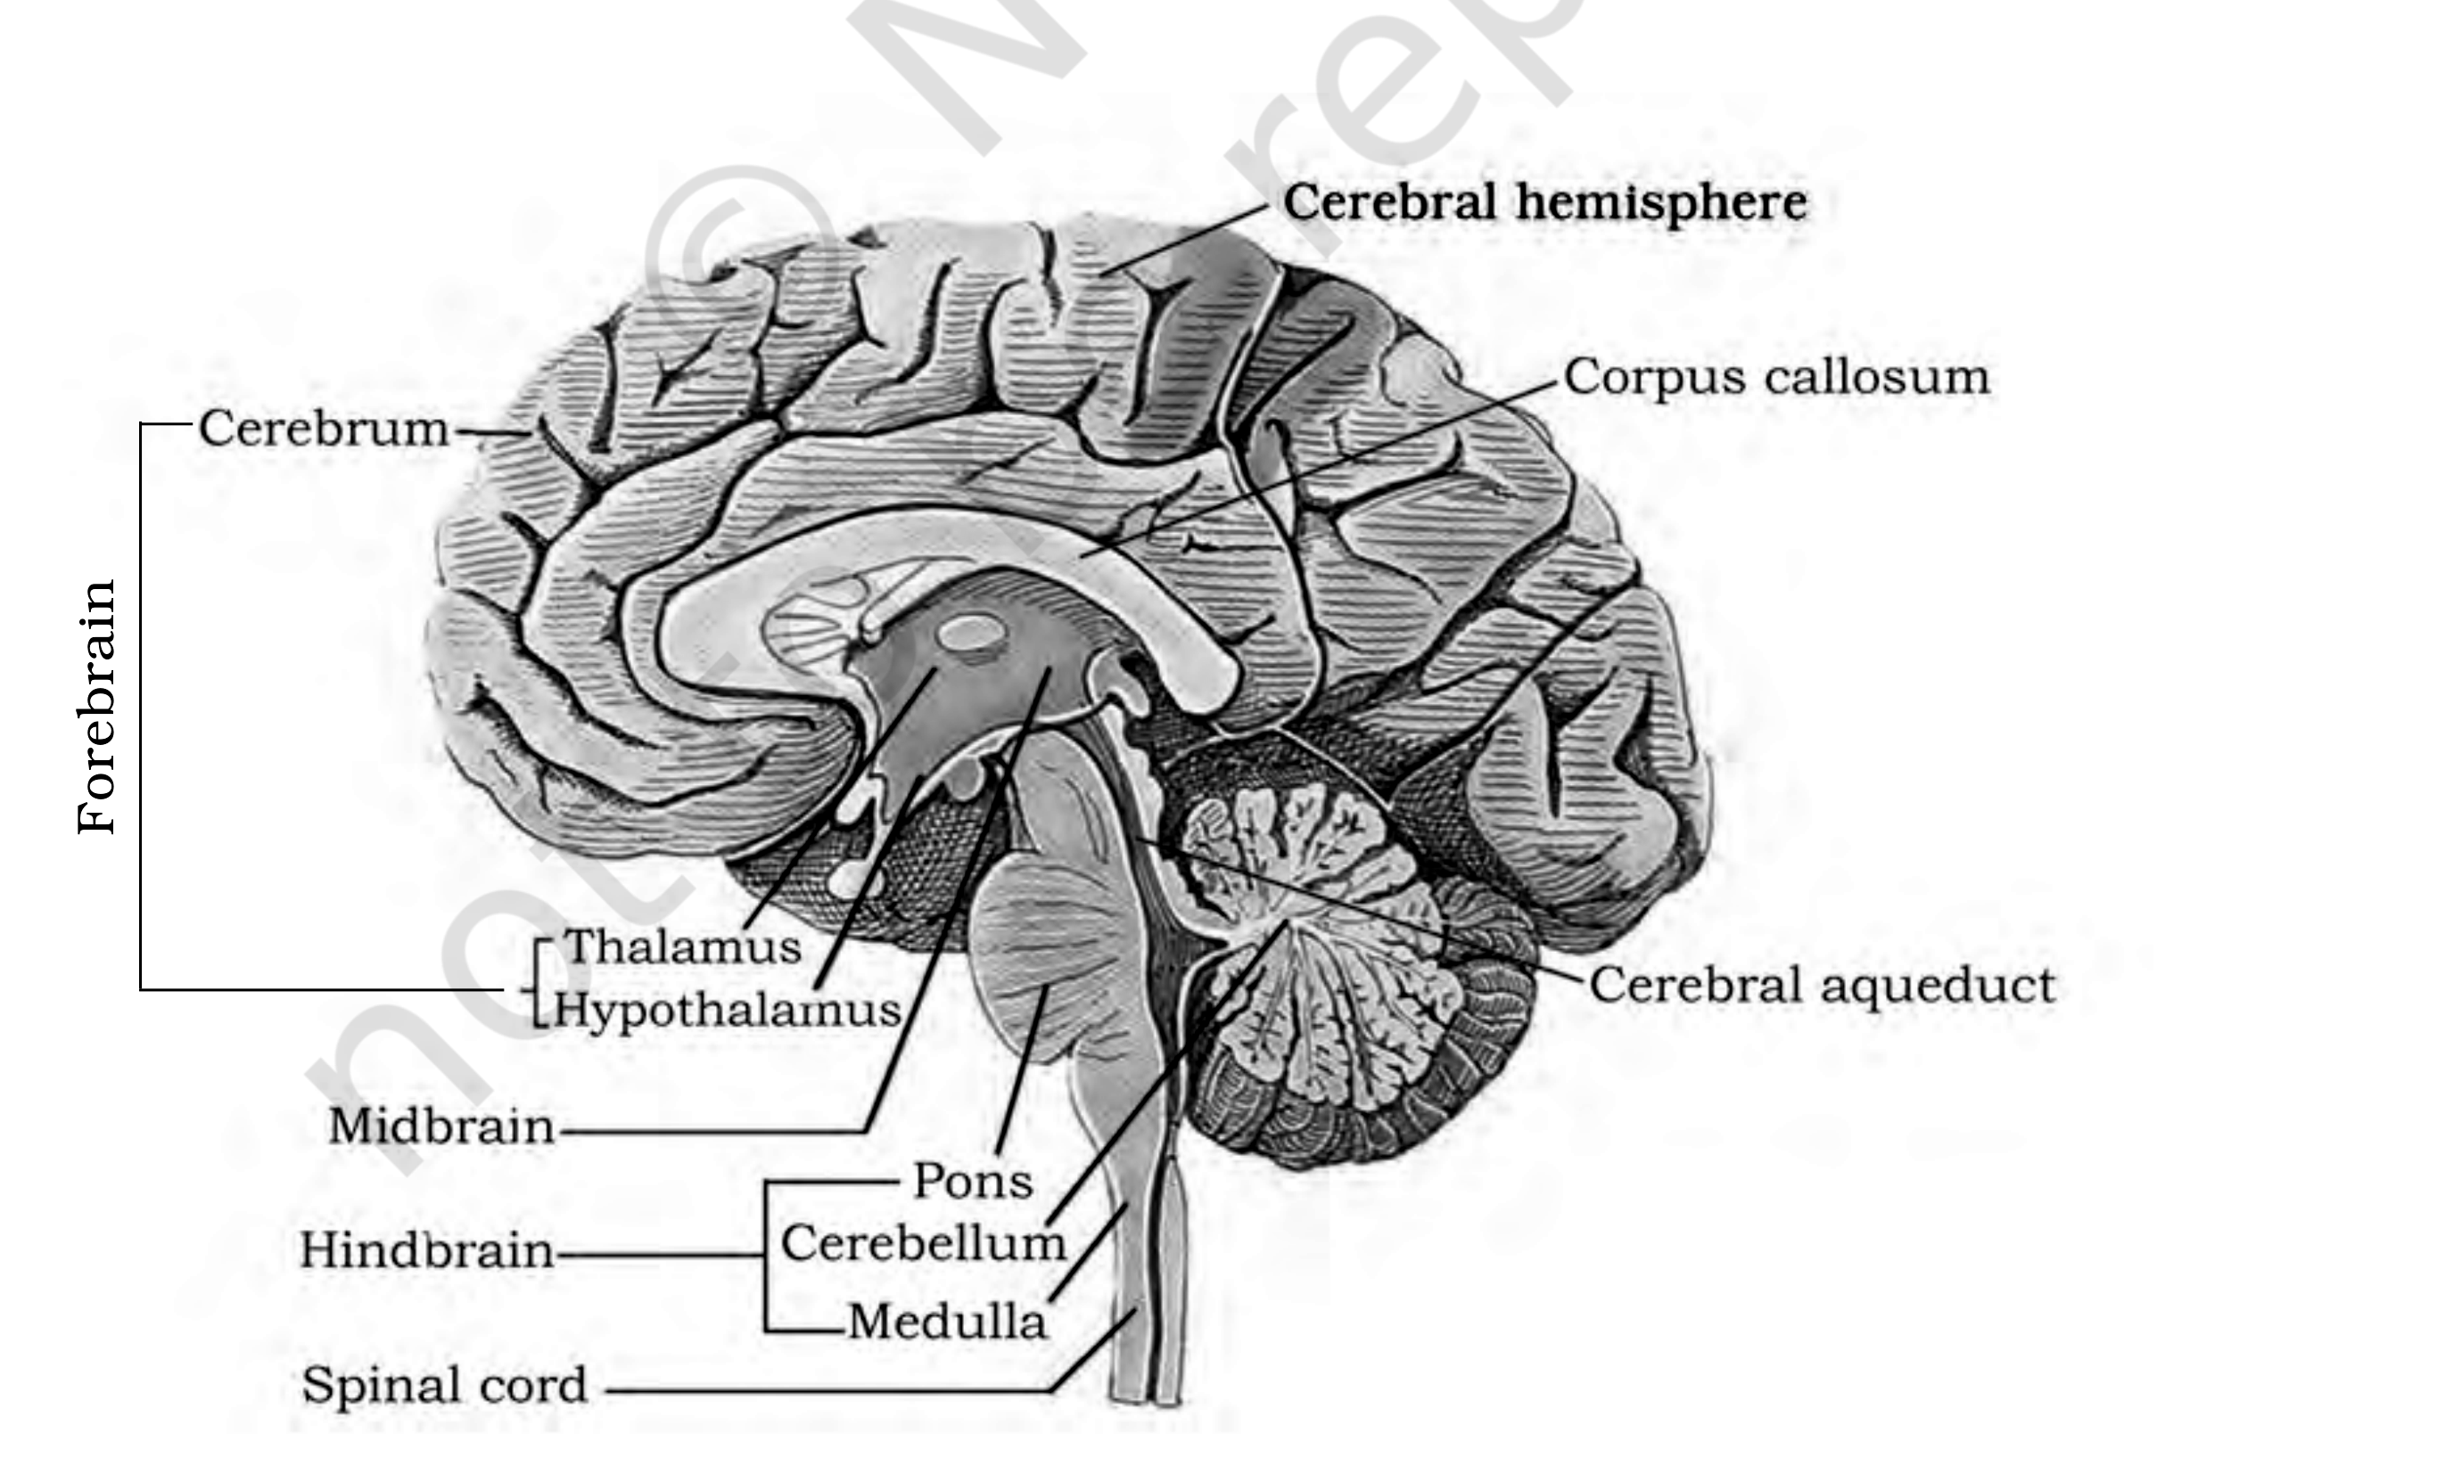
Fig. 18.4 - Diagram showing sagital section of the human brain (NCERT prints 'sagital'; the conventional spelling is 'sagittal')
18.4.1 | Forebrain

The forebrain consists of cerebrum, thalamus and hypothalamus (Figure 18.4).
• Cerebrum forms the major part of the human brain.
• A deep cleft divides the cerebrum longitudinally into two halves, which are termed the left and right cerebral hemispheres.
• Corpus callosum - the tract of nerve fibres that connects the hemispheres.
• Cerebral cortex - the layer of cells which covers the cerebral hemisphere; it is thrown into prominent folds.
Matter | What it is | Why it looks that way
Grey matter | The cerebral cortex is referred to as the grey matter | Due to its greyish appearance - the neuron cell bodies are concentrated here, giving the colour
White matter | Fibres of the tracts, covered with the myelin sheath, which constitute the inner part of the cerebral hemisphere | They give an opaque white appearance to the layer

The cerebral cortex contains motor areas, sensory areas and large regions that are neither clearly sensory nor motor in function.
• Association areas - those neither-sensory-nor-motor regions, responsible for complex functions like intersensory associations, memory and communication.
Forebrain part | Position | Function
Thalamus | The cerebrum wraps around it | A major coordinating centre for sensory and motor signaling
Hypothalamus | Lies at the base of the thalamus | Contains a number of centres which control body temperature, urge for eating and drinking; also contains several groups of neurosecretory cells, which secrete hormones called hypothalamic hormones

• Limbic lobe or limbic system - the inner parts of cerebral hemispheres and a group of associated deep structures like amygdala, hippocampus, etc., form this complex structure.
• Along with the hypothalamus, the limbic system is involved in the regulation of sexual behaviour, the expression of emotional reactions (e.g., excitement, pleasure, rage and fear) and motivation.
• The limbic system is also concerned with olfaction and autonomic responses.
[NOTE] The chapter states that the brain controls the circadian (24-hour) rhythms of our body (18.4) but never names the timekeeper. That role belongs to the hypothalamus, whose suprachiasmatic nucleus is the body's master clock - consistent with the hypothalamus already being the centre for body temperature, eating and drinking.

18.4.2 | Midbrain

• The midbrain is located between the thalamus/hypothalamus of the forebrain and the pons of the hindbrain.
• A canal called the cerebral aqueduct passes through the midbrain (NCERT prints 'passess').
• The dorsal portion of the midbrain consists mainly of four round swellings (lobes) called corpora quadrigemina.
• Function: the midbrain receives and integrates visual, tactile and auditory inputs. (Stated only in the NCERT summary; the body gives the midbrain no function at all, so it is folded in here.)
18.4.3 | Hindbrain

The hindbrain comprises pons, cerebellum and medulla (also called the medulla oblongata).
Hindbrain part | Structure | Function
Pons | Consists of fibre tracts | They interconnect different regions of the brain
Cerebellum | Has a very convoluted surface in order to provide additional space for many more neurons | Integrates information received from the semicircular canals of the ear and the auditory system (summary-only fact, folded in here)
Medulla | Connected to the spinal cord | Contains centres which control respiration, cardiovascular reflexes and gastric secretions

• Brain stem - three major regions make up the brain stem: mid brain, pons and medulla oblongata. The brain stem forms the connections between the brain and spinal cord.
[MEMORY AID - not in NCERT] Hindbrain trio - 'PCM': Pons (bridges brain regions), Cerebellum (balance-and-hearing integrator, convoluted surface), Medulla (respiration, cardiovascular reflexes, gastric secretions). Drop the cerebellum and the remaining two, with the midbrain, are exactly the brain stem.

Recap | Quick Recap (NCERT Summary, rewritten)

The neural system coordinates and integrates functions as well as metabolic and homeostatic activities of all the organs. Neurons, the functional units of the neural system, are excitable cells due to a differential concentration gradient of ions across the membrane. The electrical potential difference across the resting neural membrane is the 'resting potential'; the nerve impulse is conducted along the axon membrane as a wave of depolarisation and repolarisation.
A synapse is formed by the membranes of a pre-synaptic and a post-synaptic neuron, which may or may not be separated by a gap called the synaptic cleft. Chemicals involved in the transmission of impulses at chemical synapses are called neurotransmitters.
The human neural system consists of two parts: (i) the central neural system (CNS) and (ii) the peripheral neural system. The CNS consists of the brain and spinal cord (the NCERT summary prints 'spiral cord'). The brain divides into (i) forebrain, (ii) midbrain and (iii) hindbrain.
The forebrain consists of cerebrum, thalamus and hypothalamus. The cerebrum is longitudinally divided into two halves connected by the corpus callosum. The hypothalamus, a very important part of the forebrain, controls body temperature, eating and drinking. The inner parts of the cerebral hemispheres plus associated deep structures form the limbic system, concerned with olfaction, autonomic responses, regulation of sexual behaviour, expression of emotional reactions and motivation.
The midbrain receives and integrates visual, tactile and auditory inputs. The hindbrain comprises pons, cerebellum and medulla. The cerebellum integrates information received from the semicircular canals of the ear and the auditory system. The medulla contains centres which control respiration, cardiovascular reflexes and gastric secretions, and the pons consists of fibre tracts that interconnect different regions of the brain.
Appendix | Terms used in the exercises

Three of NCERT's exercise questions lean on something this chapter never actually states. They are answered here, and nothing in this appendix is NCERT body text - each answer names the gap it fills. Every other exercise question is answered by the sections above.
9(b) Which part of our central neural system acts as a master clock?
• The hypothalamus - specifically its suprachiasmatic nucleus - which times the brain-controlled circadian (24-hour) rhythms.
• The gap: the chapter states that the brain controls circadian rhythms, but never names the structure that keeps the time.
10(b) Impulse conduction in a myelinated nerve fibre vs an unmyelinated nerve fibre.
• In an unmyelinated fibre the membrane is depolarised at every successive point along the axon, so conduction is continuous and slower.
• In a myelinated fibre the myelin sheath insulates the axon and leaves the membrane exposed only at the nodes of Ranvier, so the impulse is regenerated node to node and leaps the insulated stretches between them - saltatory conduction, which is faster and more energy-efficient.
• The gap: 18.1 defines both fibre types and 18.3 explains conduction along an axon, but the chapter never joins the two into a conduction comparison.
10(f) Cranial nerves vs spinal nerves.
• Cranial nerves arise from the brain; spinal nerves arise from the spinal cord. Both belong to the PNS, and either may carry afferent fibres, efferent fibres or both.
• The gap: the chapter names the two together only once - as the site where myelinated nerve fibres are found - and never distinguishes them.

